Mickie Blair

Appalachian Trail – Thru Hike

Informational Guide

# Game Start Menu:

The introduction will allow the player to start a new game or to resume playing a saved game.

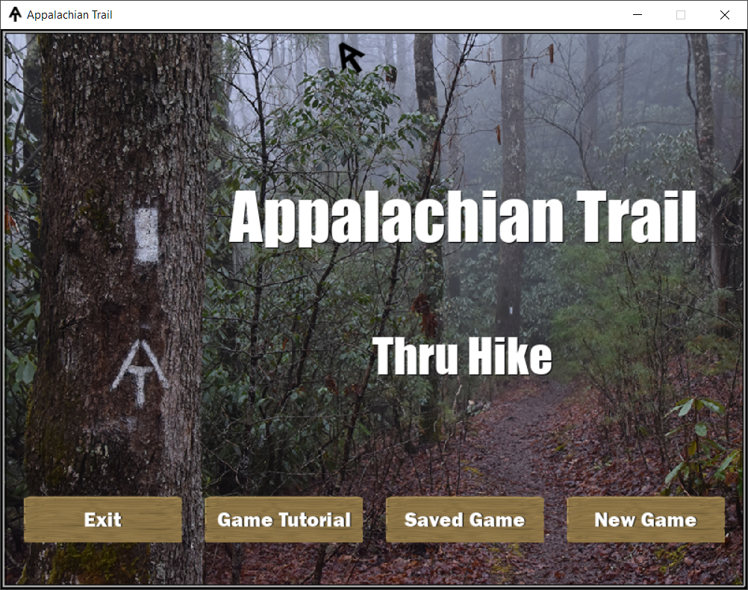

# Game Tutorial:

The game tutorial shows the player, the different aspects of the game and how to play.

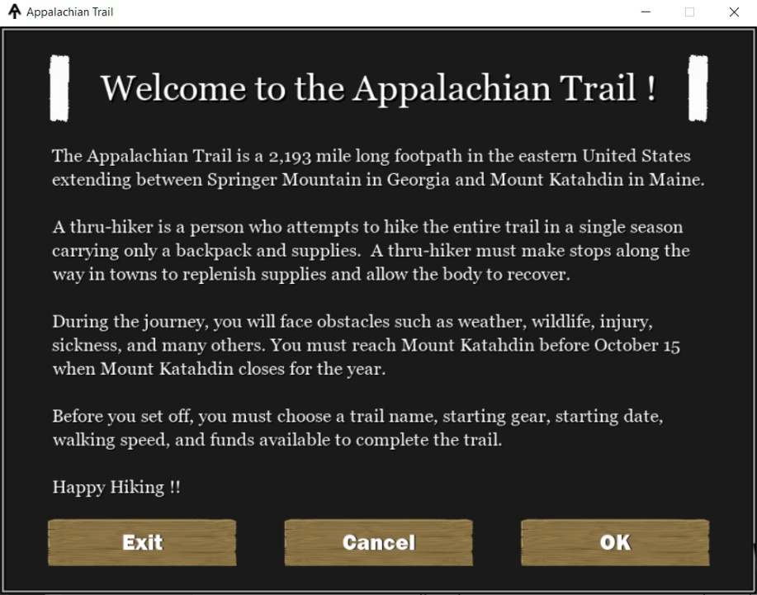

# Player Menu:

The player menu will allow the player to set the game parameters.

* Name
* Start Date
* Starting Funds
* Type of Gear
* Liters of Water
* Buy Food

The menu displays the current pack weight and funds remaining in relation to the items chosen.

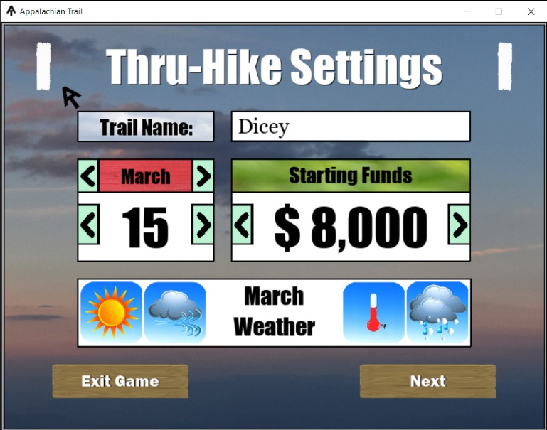

Player Menu - Screen 1

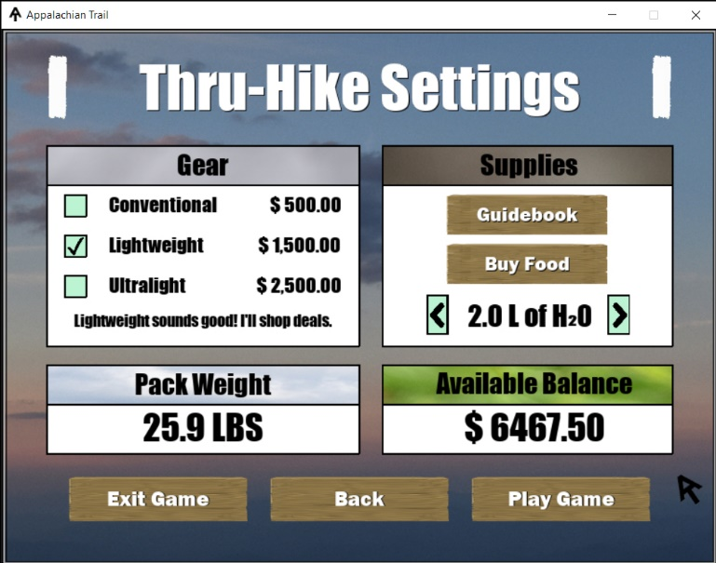

Player Menu - Screen 2

# AT Guidebook:

The player can use the guidebook link to view the distance between resupplies and the number of campsites/shelters until the next resupply point.

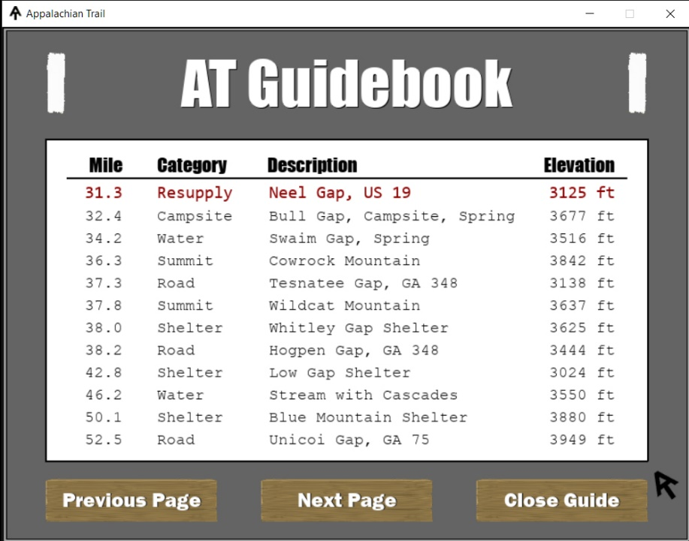

# Food Supplies:

The player can purchase meals. The screen displays the weight and cost of the food in the shopping cart.

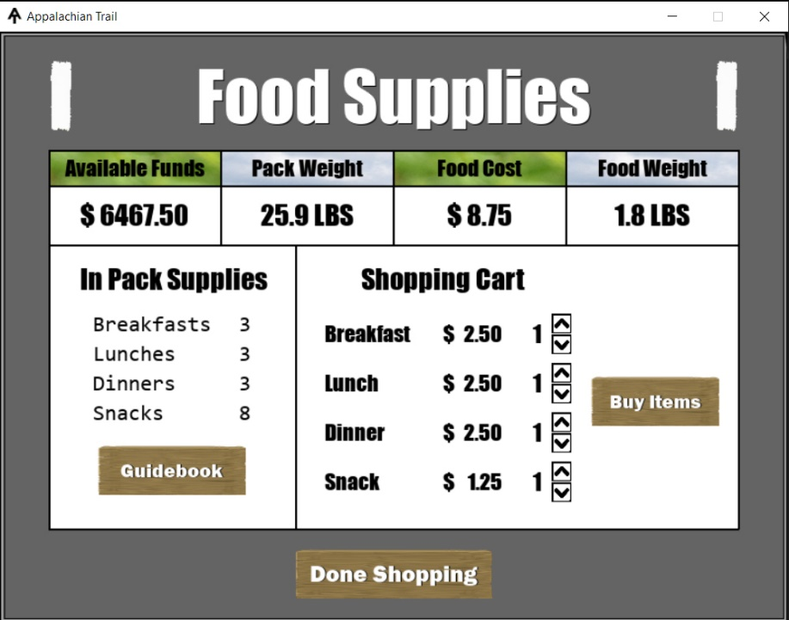

Once the food has been purchased, the player can add the food to their pack, or they can mail it ahead.

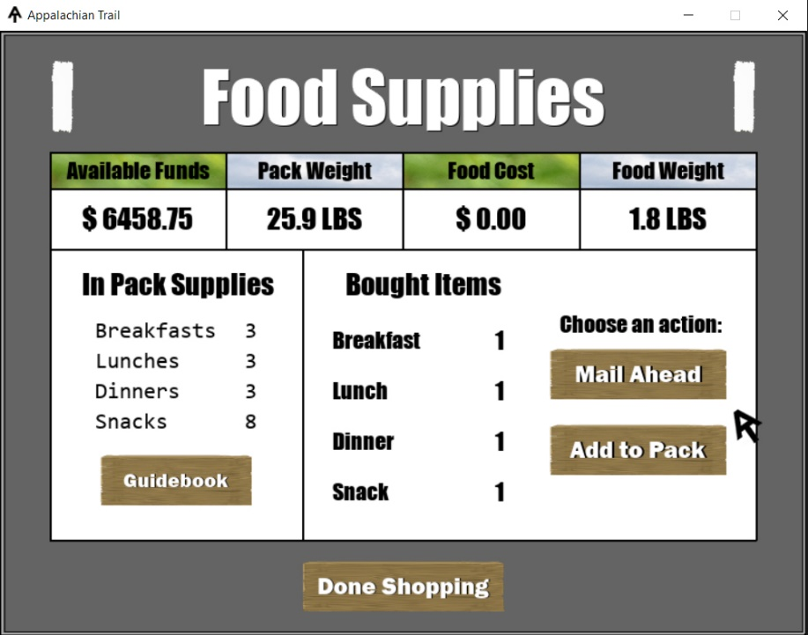

# Mailing Options:

Mailing Options shows a list of post offices and other business to mail and pick up boxes.

# Game Play:

The Initial Game Play Screen displays the player Information as well as image representing the waypoint along the trail. The player can choose to view the map, guidebook, as well choose to eat a meal or snack.

When the player reaches a waypoint, another image is displayed, and the energy and health is adjusted as necessary.

In between waypoints, a random image is displayed. Once the next waypoint is reached again, the new waypoint image is display.

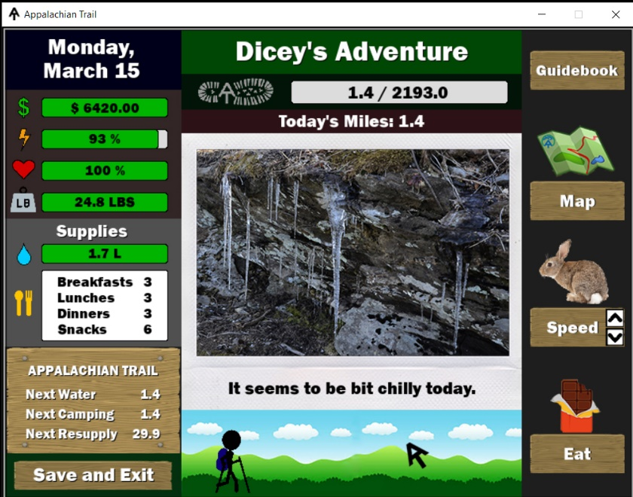

The player’s health only decreases slowly per miles unless the player is out of water. Once the water supply reaches zero, the player’s health declines rapidly. Waypoints can also generate random events such as injury or gear problems.

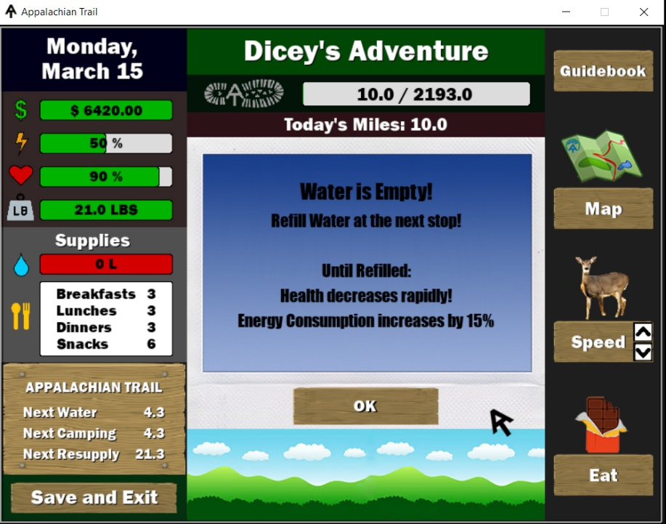

# Waypoints:

Waypoints have a specific set of action available. Players can also eat a meal to increase energy.

* Refill Water
* Sleep Here
* Resupply (Roads)

# Sleeping:

The display changes and then the date increases when the player chooses to sleep. The player’s total day mile also resets.

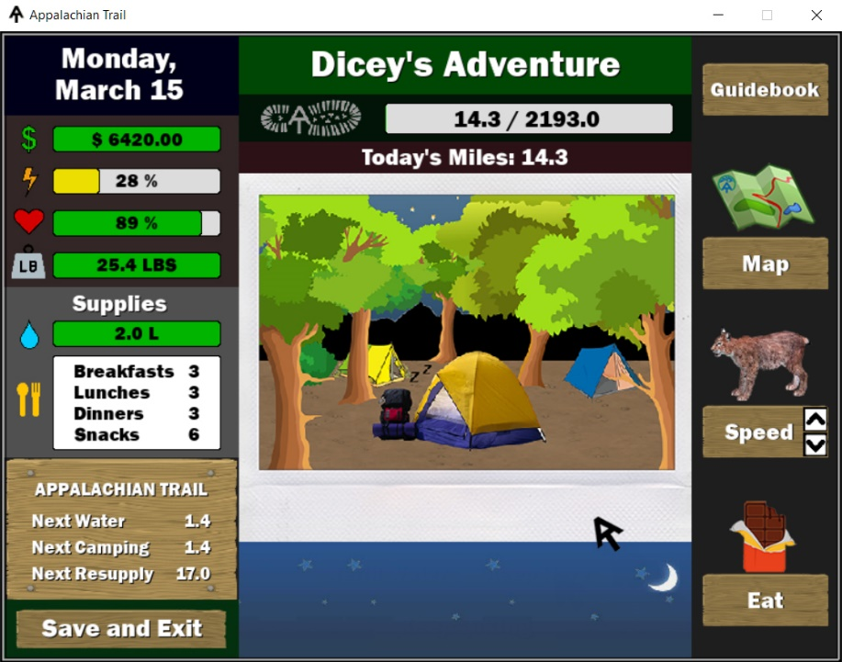

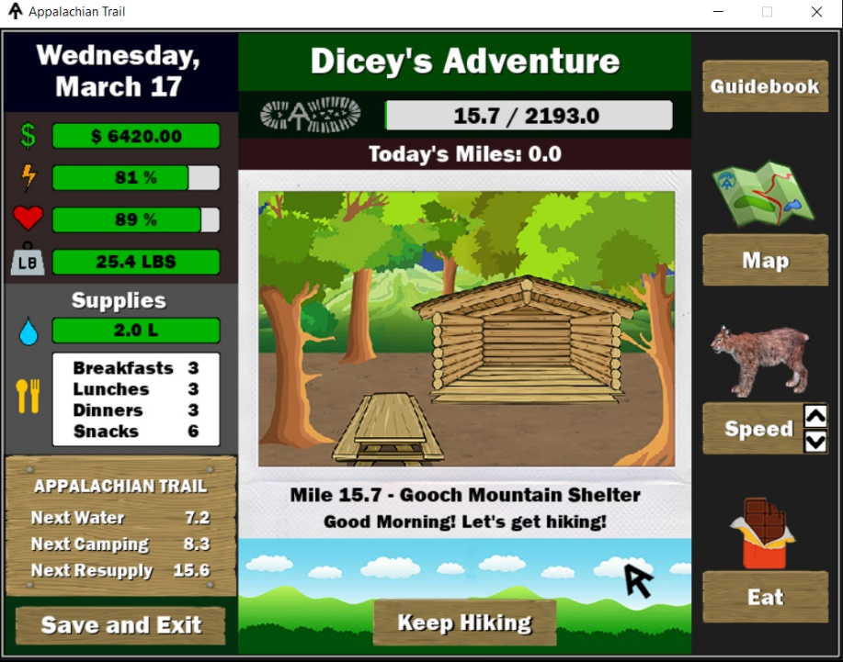

# Waypoints with Resupply:

Waypoints that have a resupply option will also the player to attempt to hitch to town.

If finding a hitch is successful, the player has the option to accept the hitch or walk to town.

If finding a hitch is unsuccessful, the player has the option to call a shuttle. If no cell signal, is available the player must walk to town.

If a shuttle is available, the price is randomly selected. The player can choose to accept the shuttle price or walk to town.

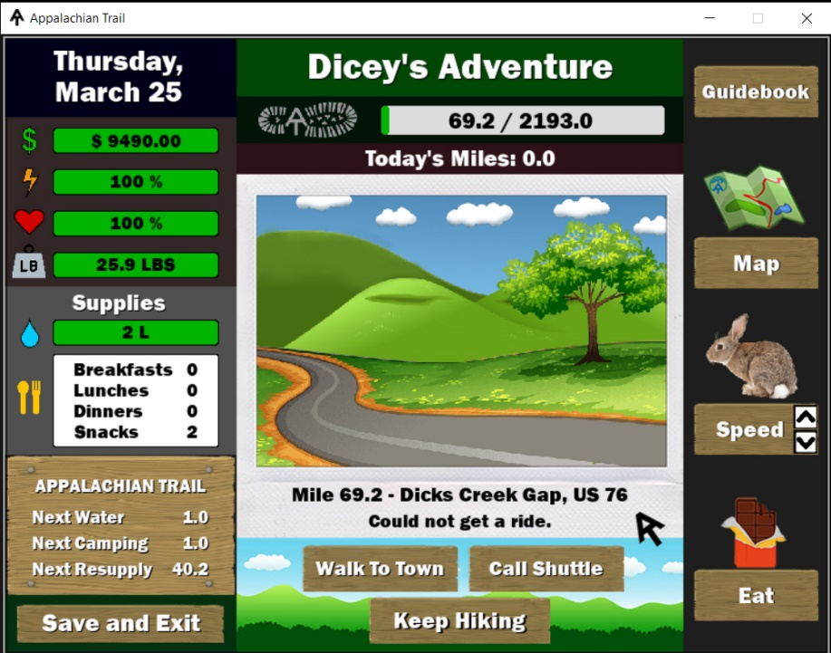

# Resupply/Town:

Once the player is in town. The player can choose from available options in town. In town, if no box has been mailed before the game may generate a random gift from a random list of people. The player gets back to the trail by hitching, walking or calling a shuttle.

# Gear Shop:

The player can purchase gear that has been used or damaged by random events. The shopping list is generated by the events.

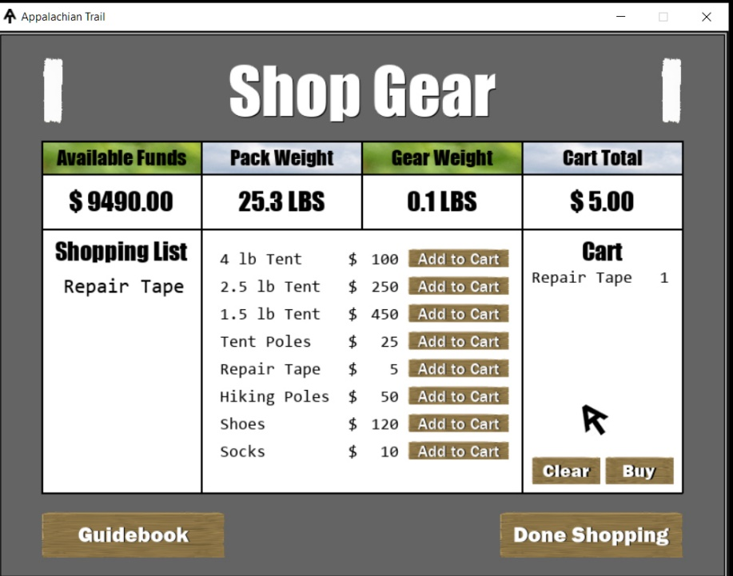

# Game Over:

If the player’s energy or health drops below zero, the players game is over. They have the option to play again. The game will also end if the player, does not ready the end by October 15.

